**Installing and Setting Up the CommuniKey Mobile Application**

Once the Administrator has updated your entry to allow app access, you will receive a text message from CommuniKey.

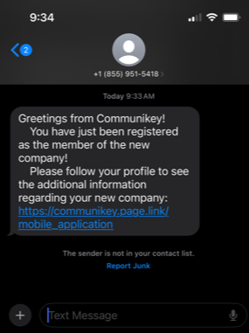

Click on the link and select INSTALL to download the CommuniKey app (CommuniKey.io) from the Apple AppStore or Google Play Store.

Once downloaded, Open the app. You will be asked to allow the app permissions:

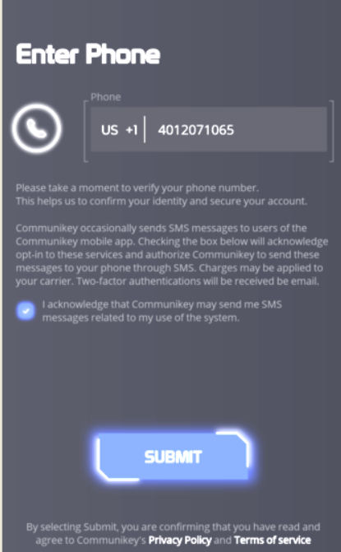

Enter the phone number of this phone. Note that you must *click on* ***acknowledge*** *and then* **SUBMIT**

The CommuniKey system will then send you an *Authorization Code* via text message to confirm the phone number.

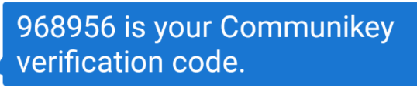

**Enter this code where requested**

Your CommuniKey app is now setup and the screen will look like this.

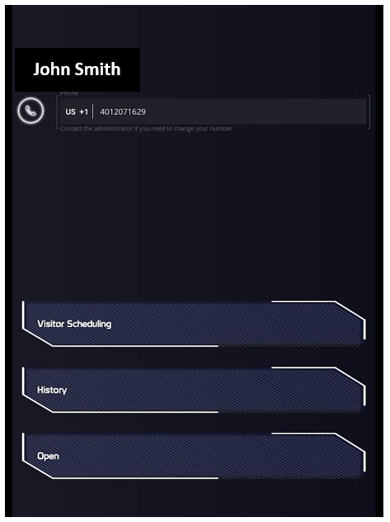

You may now close the CommuniKey app.

**Using the CommuniKey App**

When a Visitor calls you from the CommuniKey system, the app will open with a snapshot of your visitor

**

**You may select to**:

Open the gate

Answer the call and

speak to your visitor

Start a one-way video

call with your visitor

Reject the call

**Using the CommuniKey Entry System (Visitors)**

Once at the callbox, the Visitor may touch **Call a Member** (resident) to search for a resident’s name OR press **I Have a Directory Code** and enter the directory code then **Start Call**

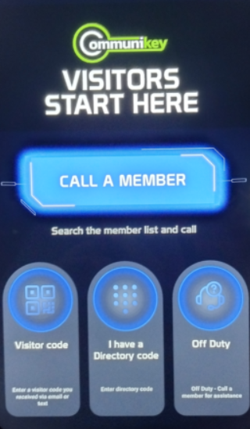

**Call a Member** will open a list of resident names in alphabetical order by last name, and a keyboard.

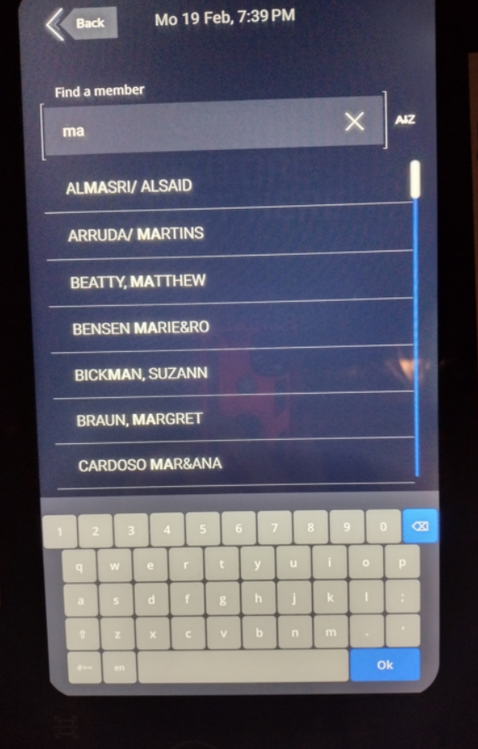

The Visitor may scroll through the names however, typing in the first few letters of the resident’s last name will bring up the resident’s name.

Touching the correct name will start a call to that resident.

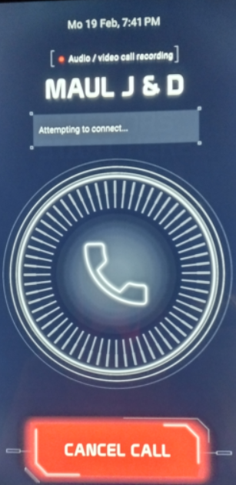

If the wrong resident is being called the visitor may touch CANCEL.

Upon receiving the call, the visitor will see:

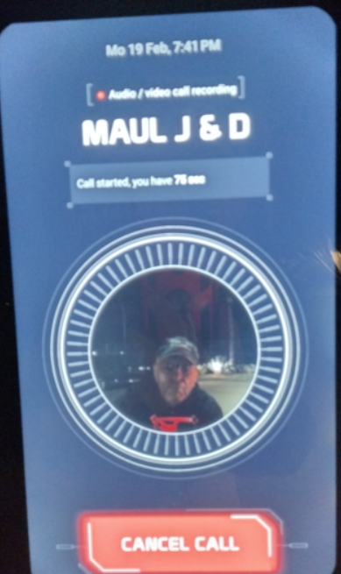

The Resident may open the Visitor’s gate and the screen will change to:

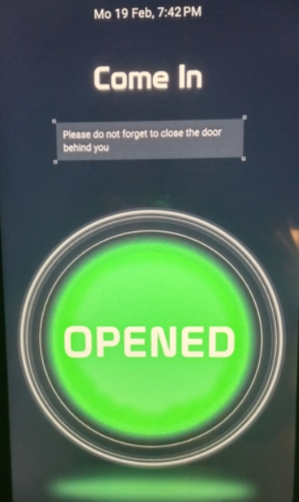

**IMPORTANT :**

If you have not received the welcome text message to download and register the app, please contact your property manager.

If you DO NOT want to use the mobile app, please let your property manager know.

**Receiving a Phone Call WITHOUT the Mobile App :**

Once a resident’s name is selected, their phone will ring and receive a call from: **954-378-3219**

Once the resident answers the call and speaks with their visitor, they may press **“1”** to open the gate (and the call will automatically disconnect) or simply hang up to disconnect the call without granting access.